**To: All Customers, Sales Representatives and Distributors**

**Date:** October 13, 2021

**Subject**: PAN 1339 CAN transceiver change Grayhill 3K Gen CANbus Keypads

This Product Advisory Notice is to alert you that Grayhill is changing the CAN transceiver used in numerous Grayhill 3K CANbus Keypads. ***Please forward this notification to the appropriate person(s) in your organization.***

**Description of Change**

Grayhill will be changing products using ON Semiconductor CAN transceiver AMIS30660CANH2RG to the next generation NXP Semiconductor CAN transceiver TJA1051T/CM,118.

**Reason for Change**

The CAN transceiver manufactured by ON Semiconductor, AMIS30660CANH2RG is at end of life. Grayhill will switch to the NXP TJA1051T. This transceiver is used extensively in many Grayhill standard and custom products having passed industry test requirements such as ESD, Radiated Emissions, Radiated Immunity, Conducted Emissions and Short Circuit exposure.

Grayhill tested the new transceiver TJA1051T on representative 3D and 3K series products. The validation included tests intended to compare performance versus the legacy design. CAN signal level comparison, ESD, and short circuit testing was performed and deemed acceptable. Grayhill also verified temperature function at operational extremes of +85C and -40C.

Based on this successful testing, Grayhill is confident the change will not affect product performance.

**Effective Date**

Grayhill is depleting our LTB of GEN 2 transceivers. Based on typical usage, the change to the new part should occur around February 2022.

**Action Required**

Please contact your Grayhill, Inc. Business Development Manager for further information.

**Part Numbers Affected**

All Grayhill Part Numbers in the attached spreadsheet below:



**TJA1051 (Replacement) SEQ2899-0062**

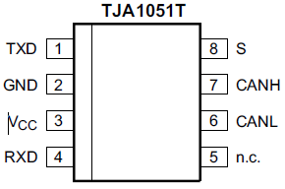

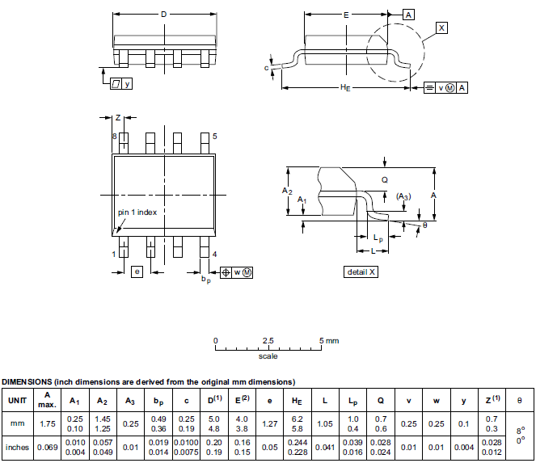

**TJA1051 (Replacement) SEQ2899-0062**

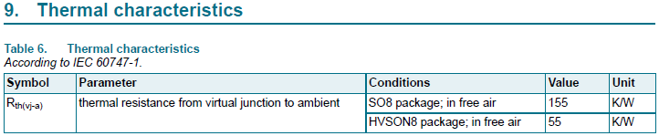



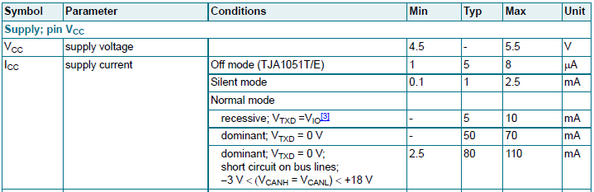



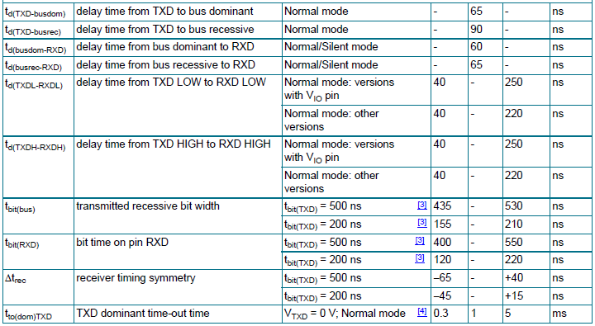

**AMIS-30660 (Current) SEQ2899-0066**

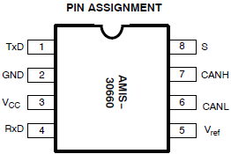

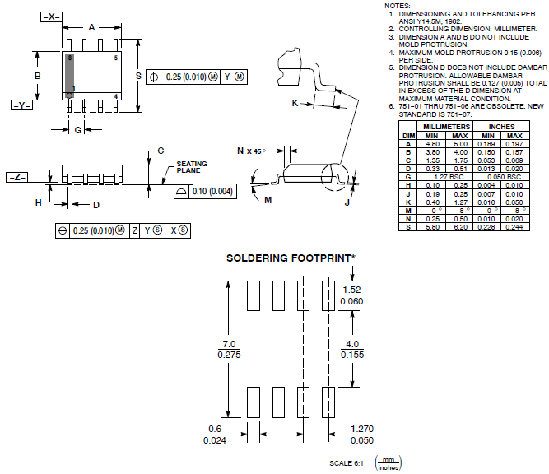

**AMIS-30660 (Current) SEQ2899-0066**

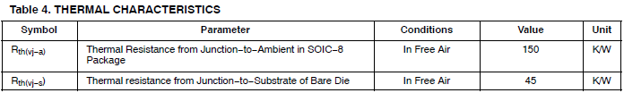











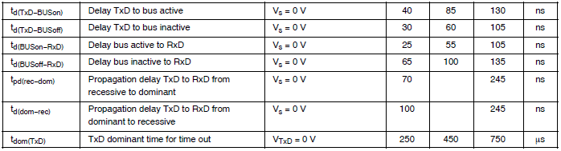

**TJA1051 (Replacement) SEQ2899-0062**

**TxD @ 22°C (Pin 1)**

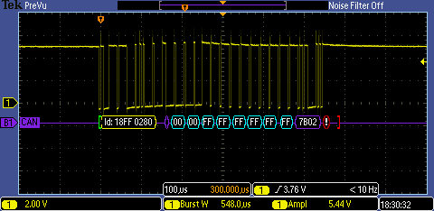

**RxD @ 22°C (Pin 4)**

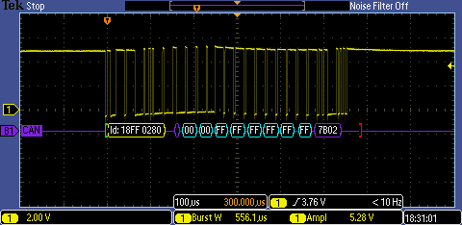

**CANL @ 22°C (Pin 6)**

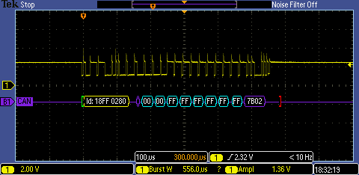

**CANH @ 22°C (Pin 7)**

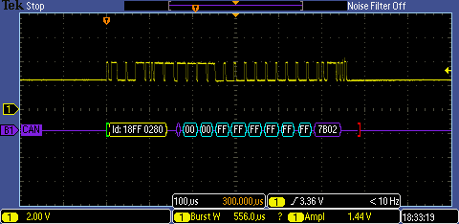

**AMIS-30660 (Current) SEQ2899-0066**

**TxD @ 22°C (Pin 1)**

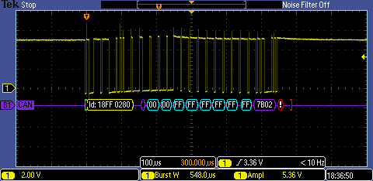

**RxD @ 22°C (Pin 4)**

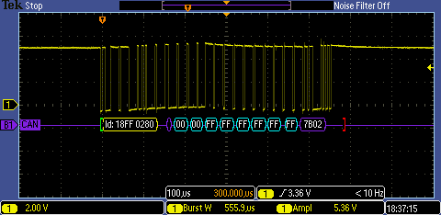

**CANL @ 22°C (Pin 6)**

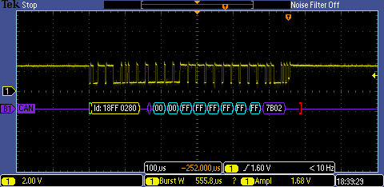

**CANH @ 22°C (Pin 7)**

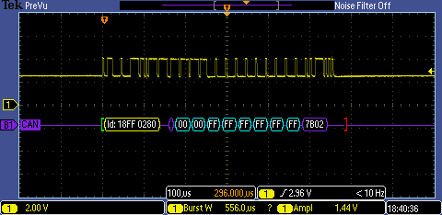

**TJA1051 (Replacement) SEQ2899-0062**

**CANL @ 22°C (Pin 6)**

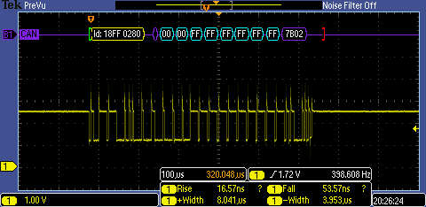

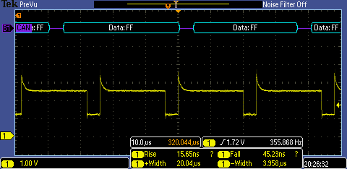

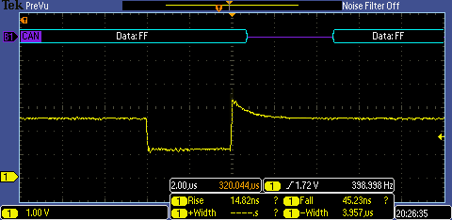

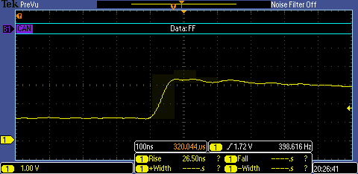

**AMIS-30660 (Current) SEQ2899-0066**

**CANL @ 22°C (Pin 6)**

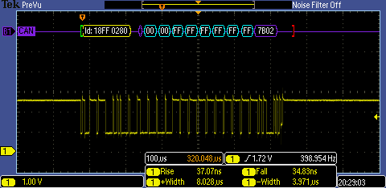

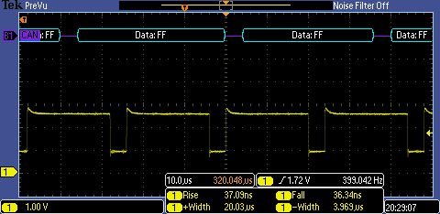

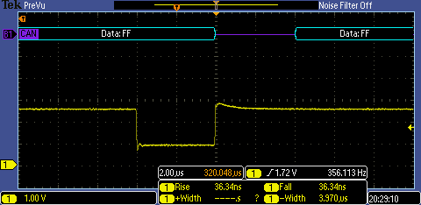

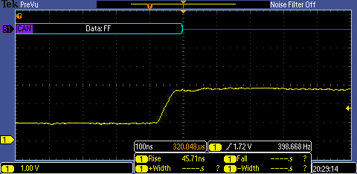

**TJA1051 (Replacement) SEQ2899-0062**

**CANL @ -40°C (Pin 6)**

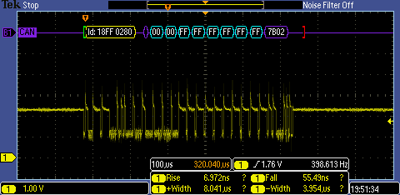

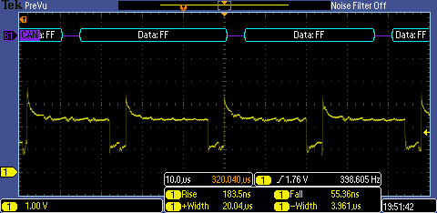

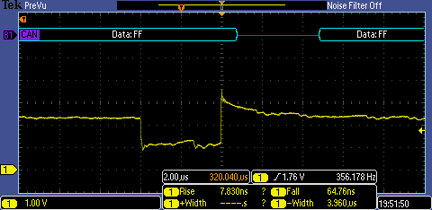

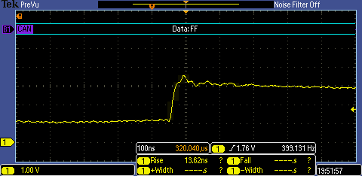

**AMIS-30660 (Current) SEQ2899-0066**

**CANL @ -40°C (Pin 6)**

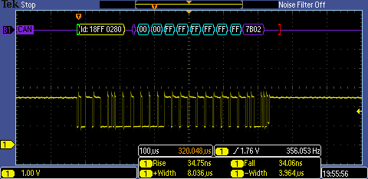

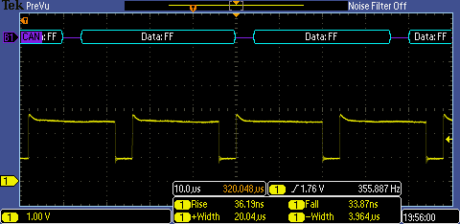

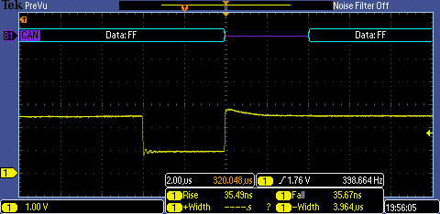

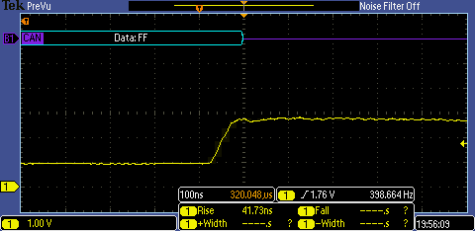

**TJA1051 (Replacement) SEQ2899-0062**

**CANL @ 85°C (Pin 6)**

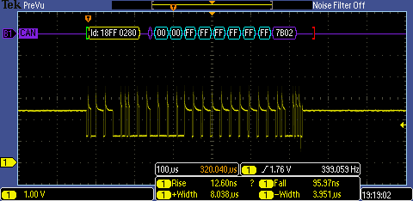

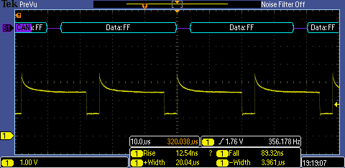

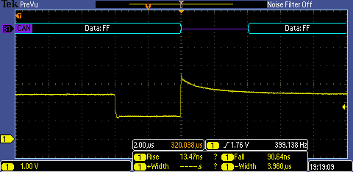

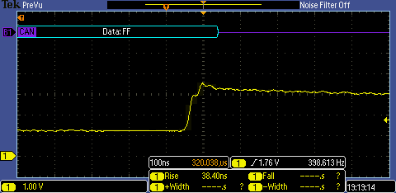

**AMIS-30660 (Current) SEQ2899-0066**

**CANL @ 85°C (Pin 6)**

